Assignment 1

Microsoft – SQL

RAKSHIT KESHRI

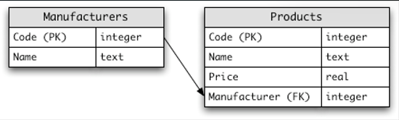

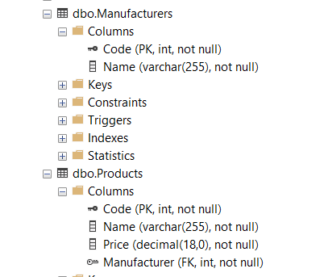

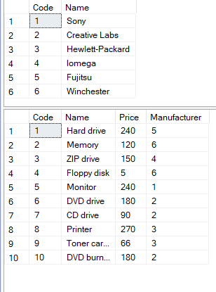

create table Manufacturers(

Code int primary key identity(1,1) not null,

name varchar(255) not null

)

--Insert Command

insert into Manufacturers values

('Sony'), ('Creative Labs'), ('Hewlett-Packard'),

('Lomega'), ('Fujitsu'), ('Winchester')

create table Products(

Code int primary key identity(1,1),

name varchar(255) not null,

price decimal(18,0) not null,

Manufacturer int not null

constraint fk_manufacturer foreign key(Manufacturer) references Manufacturers(Code)

)

--Select Command

select * from Manufacturers

select * from Products

--Insert Command

insert into Products values

('Hard drive', 240, 5), ('Memory', 120, 6), ('ZIP drive', 150, 4),

('Floppy disk', 5, 6), ('Monitor', 240, 1), ('DVD drive', 180, 2),

('CD drive', 90, 2), ('Printer', 270, 3), ('Toner card', 66, 3),

('DVD', 180, 2)

-- Question Solution

--1 Select the names of all the products in the store.

select Name from Manufacturers

--2 Select the names and the prices of all the products in the store.

select name, price from Products

--3 Select the name of the products with a price less than or equal to rs 200.

select name from products where price <= 200

--4 Select all the products with a price between rs 60 and rs 120.

select * from Products where price between 60 and 120

--5 Select the name and price in cents (i.e., the price must be multiplied by 100).

select name, price*100 as price_in_cents from Products

--6 Compute the average price of all the products.

select avg(price) from products

--7 Compute the average price of all products with manufacturer code equal to 2.

select avg(price) from products where Manufacturer = 2

--8 Compute the number of products with a price larger than or equal to rs 180.

select count(*) from products where price >=180

--9 Select the name and price of all products with a price larger than or equal to rs 180, and sort first by price (in descending order), and then by name (in ascending order).

select name, price from products

where price >= 180

order by price desc, name asc

--10 Select all the data from the products, including all the data for each product's manufacturer.

select * from

products p

full join

manufacturers m

on p.manufacturer = m.code

--11 Select the product name, price, and manufacturer name of all the products.

select p.name, p.price, m.name from

products p

left join

manufacturers m

on

p.Manufacturer = m.Code

--12 Select the average price of each manufacturer's products, showing only the manufacturer's code.

--sol 1

select manufacturer, cast(avg(Price) as decimal(10,2))

Avg_price from products group by Manufacturer

--sol 2

select m.code, cast(avg(Price) as decimal(10,2)) from

Manufacturers m

left join

products p

on

m.Code = p.Manufacturer

group by m.Code

--13 Select the average price of each manufacturer's products, showing the manufacturer's name.

select m.name, avg(price) from

Manufacturers m

left join

Products p

on

m.Code = p.Manufacturer

group by m.name

--14 Select the name and price of the cheapest product.

select name, price from Products

where price in (

select min(price) from Products

)

select name, price from Products where

price = (select min(price) from products)

--15 Select the name of each manufacturer along with the name and price of its most expensive product.

select m.name, max(price) from

Manufacturers m

left join

Products p

on

p.Manufacturer = m.Code

group by m.name

--16 Add a new product: Loudspeakers, rs 70, manufacturer 2.

insert into Products values ('Loudspeakers', 70, 2)

--17 Update the name of product 8 to "Laser Printer".

update Products set name = 'Laser Printer' where Code = 8

--18 Apply a 10% discount to all products.

select name, price-(price*0.1) as discounted_price from products

--19 Apply a 10% discount to all products with a price larger than or equal to rs 120.

select name, price-(price*0.1) as discounted_price from products

where price >= 120